The Tornado that Turned into a Cat
Lynne McIlvride’s Price List
*Please note all sales are made through the artist only. If Lynne is not in the gallery, she can be contacted at LynneMcilvride@icloud.com.
This list will also be available on LynneMcilvrideArt.wordpress.com. Eventually.

- Keep an Eye on the Sky, 2013, acrylic on paper construction and wood, NOT FOR SALE

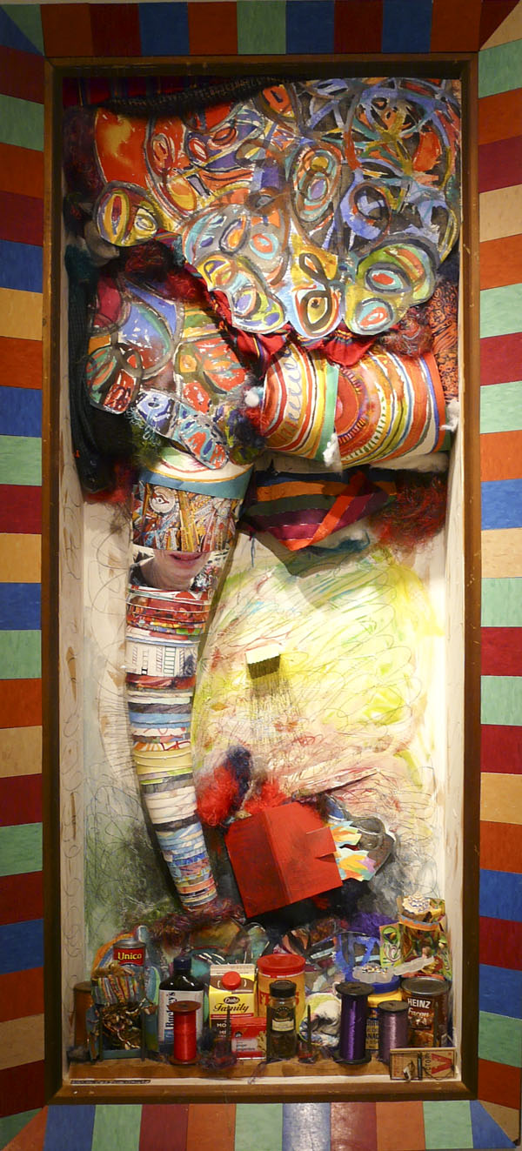
- Giant Tornado, 2013-2015, mixed media constructed painting and installation, $3000.00

- Everybody Sees You’re Blown Apart, 2013, mixed media and paper construction, photograph, $600.00

- Tornado Cabinet, 2013, mixed media, $2600.00

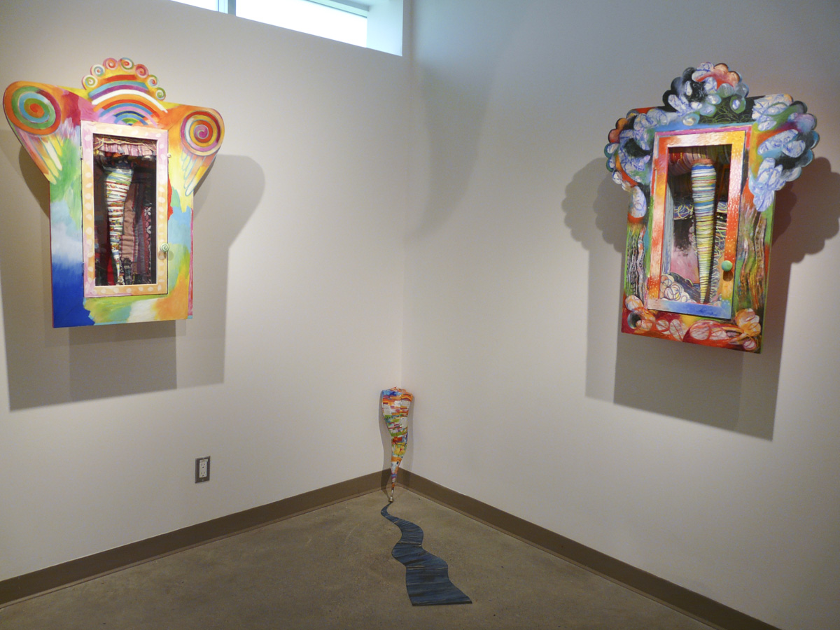
- Catastrophe, 2015, mixed media installation, $800.00

- Storm Charmers, 2013, mixed media, $2600.00

- A Disaster Waiting to Happen, 2013, mixed media, $2600.00

- !, 2013, mixed media, found objects, $2600.00

- Look! No Hands! 2013, NOT FOR SALE

- Do Not Be Terrified, 2013, mixed media, $2600.00

- Blooming Tornado!, 2013, mixed media, fresh flowers, $2600.00

- The Turning, 2014, mixed media paper construction, $2000.00
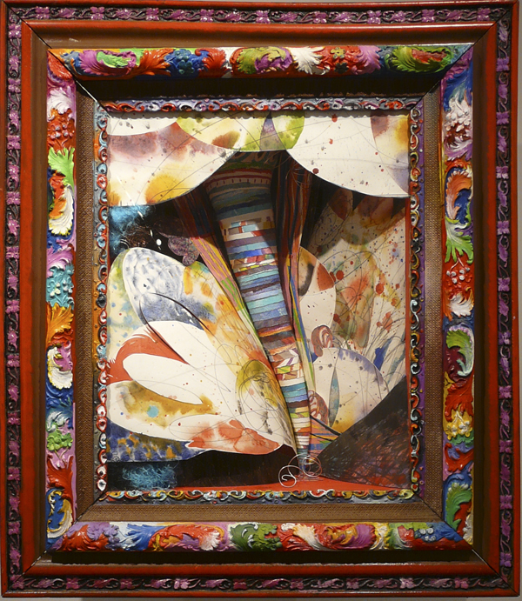
- Touching Down, 2014, mixed media paper construction, $1500.00

- Turn, Turn, Turn, 2014, mixed media paper construction, $1000.00

- Inside the Tornado 1, 2015, acrylic and watercolour on paper, oil on glass, $200.00

- Inside the Tornado 2, 2015, acrylic and watercolour on paper, oil on glass, $300.00

- Inside the Tornado 3, 2015, acrylic and watercolour on paper, oil on glass, $550.00

- Inside the Tornado 4, 2015, acrylic and watercolour on paper, oil on glass, $550.00

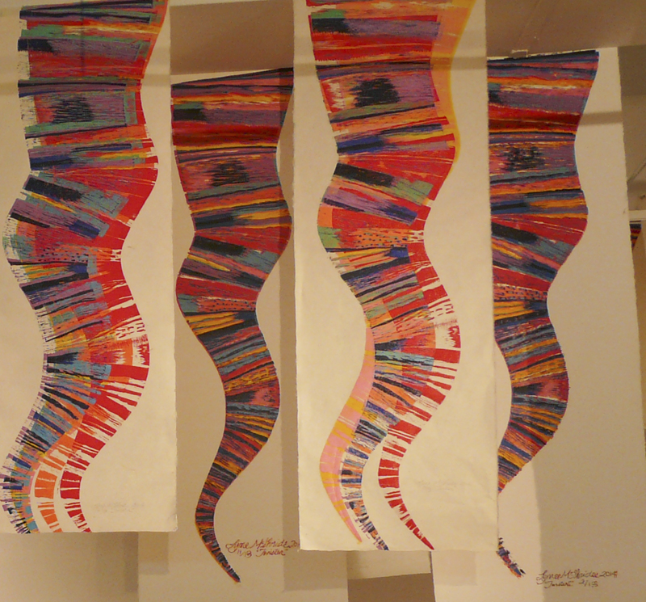
- Flying Colours is a an installation made of reduction linoprints. These individual original prints are for sale. The largest ones are$200 each, the medium $150.00 and the smallest (Walking Tornados) are $75.00 each.
- Twister Sleeping, opaque watercolour on paper construction, oil on frame, 2015, $950.00
- Step 1: Terror, 2015, opaque watercolour on paper constructions, silver leaf on glass, 2015, $500.00
- Step 2: Knowing Up from Down, 2015, opaque watercolour on paper constructions, silver leaf on glass, 2015, $500.00
- Step 3: Twist! opaque watercolour on paper constructions, silver leaf on glass, 2015, $500.00
- She Lands on her Feet, 2015, opaque watercolour on paper construction, gold leaf on glass, $1500.00
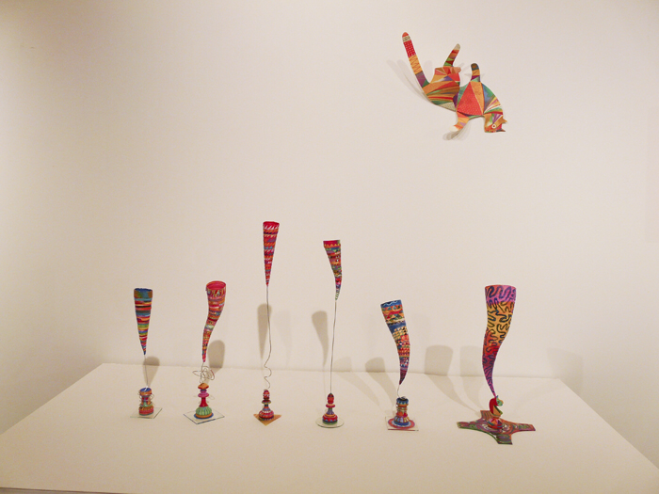
- Pocket Tornados, $250 each
- ……Angel Having a Bath, 2015, $950.00
- Small Cat Landing, 2015, NOT FOR SALE
- Domestic Tornado 1, 2014, free- hanging fibre sculpture,$1000.00
- Domestic Tornado 2, 2014, free-hanging fibre sculpture, NOT FOR SALE
- Domestic Tornado 3, 2014, free- hanging fibre sculpture,$500..00
- Domestic Tornado 4, 2014, free- hanging fibre sculpture,$800..00
- Domestic Tornado 5, 2014, free- hanging fibre sculpture, $1000.00
- Domestic Tornado 6, 2014, free- hanging fibre sculpture, $700.00
- Mixed Metaphor, 2014-2015, sculptural installation, $2000.00

